Oration Awards—2026


The EC of ISHA takes the pride in recognizing the following eminent professionals for the Orations and Travel Fellowship for the year 2026.
Award Ceremony: 57th ISHACON 2026
Place: Ahmedabad, Gujarat
Dr. S. R. Chandrasekhar Travel Fellowship (2025) to
Ms. Sucheta Kamath
Founder ExQ and CEO
USA
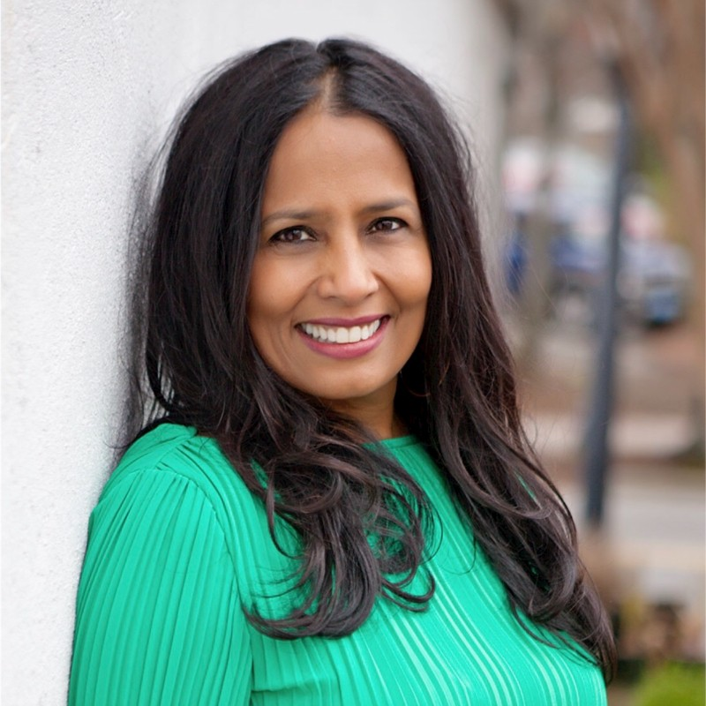
Padma Shri Prof. S. Kameswaran Endowment
Oration (2025) to Dr. Rashmi J. Bhat (L11030272)

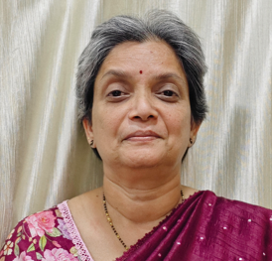

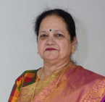

Prof. R. K. Oza Oration (2025) to
Dr. Gurmit Kaur Bachher (L11030197)

Dr. N. Rathna Oration (2026) to
Dr. Lakshmi Venkatesh (L11050644)

